

Bachelor of Science in Information Technology

Muhammad Adil
2021-GU-820

Department of Computer Science & IT Ghazi University, Dera Ghazi Khan, Pakistan.
May, 2025

This project report is submitted to Department of Computer Science & IT, Ghazi University, Dera Ghazi Khan in partial fulfillment of the requirements for the degree of Bachelor of Science in Information Technology (BSIT).
Student’s Name: Muhammad Adil
Registration No. 2021-GU-820

Supervised by:
Dr. Muhammad Abubakar Siddique



Department Computer Science & IT Faculty of Sciences
Ghazi University, Dera Ghazi Khan, Pakistan.
May, 2025

I Muhammad Adil having registration no. 2021-GU-820 hereby state that this project report entitled “Online Cosmetic Store” is my own work and has not been submitted previously for any degree from Ghazi University, Dera Ghazi Khan, or elsewhere in the country/world. If my statement is found incorrect even after graduation, the university has the right to take action against me as per approved rules and regulations of the University.

Signature of the candidate

This is to certify that we have read this report submitted by Muhammad Adil and it is my judgment that this report is of sufficient standard to warrant its acceptance by Ghazi University, Dera Ghazi Khan for the degree of BS (Information Technology).

Committee:

- External Examiner

Mr. Professor Department of CS & IT
Ghazi University, D.G. Khan

- Supervisor
Dr. Muhammad Abubakar Siddique Associate Professor
Ghazi University, D.G. Khan

- Head of Department
Dr. Hafiz Gulfam Ahmad Umar Associate Professor
Ghazi University DG Khan

I would like to express my deepest gratitude to my supervisor, Dr. Muhammad Abubakar Siddique, for his invaluable guidance, support, and encouragement throughout the research and composition of this thesis. His expertise and insights have been instrumental in shaping this work.

I would also like to thank my teachers and mentors at the Department of Computer Science & IT, Ghazi University, Dera Ghazi Khan, for their continuous support and for providing a strong foundation in my field of study.

A special thanks to my colleagues and friends for their unwavering support, encouragement, and constructive feedback throughout this journey.

Lastly, I am profoundly grateful to my family, especially my parents, for their endless support, patience, and belief in my abilities, which have motivated me to persevere and complete this work.

Muhammad Adil

The Online Cosmetic Store is an innovative e-commerce platform designed to streamline and enhance the shopping experience for beauty and skincare enthusiasts. Built using HTML, CSS, JavaScript, PHP, and MySQL, this system addresses the challenges of traditional cosmetic retail by offering a convenient, efficient, and user-friendly digital shopping environment.

The system provides a centralized platform for customers and administrators. Customers can browse a wide range of products, view detailed descriptions, add items to their cart, and complete purchases using secure payment options. Additionally, the platform supports user registration, enabling customers to track orders and access personalized recommendations based on their preferences.

For administrators, the system includes a robust backend to manage inventory, process orders, and update product details effortlessly. Administrators can also monitor sales trends, manage customer queries, and ensure a seamless operational workflow.

The Online Cosmetic Store eliminates the limitations of physical stores by offering 24/7 availability, a diverse product range, and intuitive navigation. By integrating these features into a single platform, the system aims to improve customer satisfaction, boost sales, and simplify business operations. Its scalable and adaptable design ensures it can accommodate future growth and evolving market demands.

Keywords: Online Cosmetic Store, e-commerce platform, PHP, MySQL, web development, customer satisfaction, inventory management, digital shopping experience.

Table of Contents

1.4 Project Scope 2
1.5 Advantages of the Proposed Solution 3
1.6 Chapter Summary 4
1.1 Existing System 6
2.2 Drawbacks of the Existing System 6
2.3 Proposed System 7
2.4. Benefits of the Proposed System 8
2.5. Need to Replace the Existing System 10
2.6. Chapter Summary 12
3.1 Introduction 14
3.2 Understanding the System 14
3.3 Advantages of the Proposed System 16
3.4 Hurdles to Optimize the Current System 17
3.5 Functional Requirements 18
Non-Functional Requirements 20
3.6 Chapter Summary 20
4.1 Software Process Model 22
4.2 Benefits of Selected Model 23
4.3 Limitations of Selected Model 24
4.4. Design 25
4.4.1. Data Flow Diagram (DFD) 26
4.4.2. Entity Relationship Diagram (ERD) 28
4.4.3. Class Diagram 30
4.4.4 UML Diagram 31
Actors: 31
Use Cases: 32
Explanation: 32
Summary 33
4.4.5. Sequence Diagram 34
4.4.6. Activity Diagram 35
4.5. Chapter Summary 37
5.1 Introduction to Database 40
5.2 Why SQL? 41
5.3 Database Structure 41
6.1 Introduction 44
6.2 Setting Up the Development Environment 44
6.3 Implementation of Key Features 47
2. Dynamic Product Display 50
3. Product Search Functionality 51
4. Shopping Cart 51
5. Checkout and Order Placement 53
6. Admin Panel and Dashboard 54
8. Image and Slider Management 54
9. Contact Form and Feedback Handling 55
10. Logout and Session Handling 56
7.1 Introduction 58
7.2 Testing Strategies 58
1. Unit Testing 58
2. Integration Testing 59
3. System Testing 59
4. Functional Testing 59
5. User Interface Testing 60
6. Security Testing 60
7. Database Testing 60
8. Cross-Browser Testing 61
9. Responsive Testing 61
7.2.1 Unit Testing 62
7.2.2 Integration Testing 63
7.2.3 System Testing 65
7.3 Acceptance Testing 66
7.4 Test Cases 67
7.5 Testing Tools 69
7.5 Testing Tools 69
7.6 Testing Results 70
7.7 Chapter Summary 71
• 8.1 Introduction 72
• 8.2 Achievement of Objectives 72
• 8.3 Improved Administrative Efficiency 73
• 8.4 Enhanced Customer Management and Experience 73
8.5 Effective Communication 74
8.6 Benefits to Users 74
8.7 Performance Evaluation 75
8.8 Limitations and Areas for Improvement 76
8.9 Chapter Summary 77
REFERENCES 78

LIST OF FIGURES

Figure 4.1: Software Development Models 22
Figure 4.2: Data Flow Diagram 27
Figure 4.3: ER Diagram 29
Figure 4.4: Class Diagram 30
Figure 4.5: UML Diagram 32
Figure 4.6: Sequence Diagram 34
Figure 4.7: Activity Diagram 36
Figure 5.1: Database Structure 42
Figure 6.1: User Registration 48
Figure 6.2: Login System 48
Figure 6.3: User Registration(Code) 49
Figure 6 4: Login System(Code) 49
Figure 6.5: Dynamic Product Display 50
Figure 6.6: Dynamic Product Display(Code) 50
Figure 6.7:Product Search Functionality 51
Figure 6.8: Product Search Functionality(Code) 51
Figure 6.9:Shopping Cart 51
Figure 6.10: Shopping Cart(Code) 52
Figure 6.11:Checkout And Order Placement 52
Figure 6.12: Checkout And Order Placement(Code) 53
Figure 6.13:Admin Panel And Dashboard 53
Figure 6.14:Image And Slider Management 54
Figure 6.15: Image And Slider Management(Code) 54
Figure 6.16:Contact Form And Feedback Handling 54
Figure 6. 17: Contact Form And Feedback Handling(Code) 55
Figure 6. 18:Logout And Session Handling 55
Figure 6. 19:Category Product Management 56

INTRODUCTION

1.1 Introduction
The Online Cosmetic Store is a specialized e-commerce platform developed to meet the rising demand for online shopping in the beauty and skincare industry. With digital technology reshaping consumer behavior, this system offers a seamless way for customers to browse, select, and purchase products online.
Traditional retail is limited by store locations, operating hours, and inventory issues. For businesses, maintaining physical stores often incurs high costs and operational challenges. This online platform addresses these issues by connecting customers and businesses digitally.
Built using PHP, HTML, CSS, JavaScript, and MySQL, the system ensures a smooth experience for users and administrators. Customers enjoy detailed product browsing and secure transactions, while businesses benefit from tools for inventory, sales, and customer management. The platform aims to transform the shopping experience and support business growth in the digital age.
1.2 Project Statement
Traditional cosmetic shopping poses challenges such as:
- Geographical constraints limiting product access.
- Limited accessibility due to store hours.
- Inventory management difficulties.
- Lack of customer insights on buying behavior.
The Online Cosmetic Store addresses these by offering a scalable, user-friendly e-commerce solution that:
- Provides 24/7 access to a wide range of products.
- Allows efficient inventory and order management.
- Ensures secure transactions and data protection.
- Offers personalized recommendations and easy navigation.
The platform is built to meet current demands and evolve with future market trends.

1.3 Objectives
- Enhance Customer Experience:
User-friendly interface, product comparisons, reviews, and detailed descriptions.
- Streamline Business Operations:
Simplified inventory, product, and order management through an admin dashboard.
- Ensure Accessibility:
Compatible with desktops, tablets, and smartphones for anytime, anywhere shopping.
- Promote Scalability:
Designed for growth, supporting product expansion and feature integration.
- Ensure Security:
Implements secure login systems and payment gateways to protect user data.
- Boost Business Growth:
Expands reach, analyzes sales data, and supports revenue growth strategies.

1.4 Project Scope
The Online Cosmetic Store includes the following core functionalities:
Customer Features:
- User Registration & Login: Secure account creation and profile management.
- Product Browsing & Search: Browse by category, filter by price, brand, or type, and search for specific items.
- Shopping Cart & Checkout: Add items to cart and complete purchases using secure online payment methods.
- Order Tracking: View real-time order status and access order history.
- Wishlist: Save products for future consideration.

Administrator Features:
- Inventory Management: Add, update, delete products, manage stock, and organize items.
- Order Management: Process, approve, and track orders efficiently.
- Reports & Analytics: Generate sales reports and track customer behavior.
- Customer Feedback Management: Respond to inquiries, complaints, and reviews.
Technology Scope:
- Backend: PHP and MySQL for server-side functionality and database management.
- Frontend: HTML, CSS, and JavaScript for a responsive, user-friendly interface.
- Payments: Integration with secure gateways (e.g., PayPal, Stripe).
- Device Compatibility: Fully responsive design across desktops, tablets, and smartphones.

1.5 Advantages of the Proposed Solution
The platform offers several key benefits over traditional retail methods:
- Customer Convenience: 24/7 access without location or time constraints.
- Efficient Inventory Management: Real-time stock control prevents shortages and overstocking.
- Business Cost Savings: Reduces the need for physical stores, cutting operational costs.
- Enhanced Engagement: Reviews, ratings, and recommendations increase customer satisfaction.
- Data-Driven Decisions: Analytics help identify trends and guide marketing strategies.
- Scalability: Supports business growth with seamless handling of increased users and products.
- Security: Encrypted transactions and trusted gateways protect customer data.
- Global Reach: Expands business beyond local markets to a broader online audience.

1.6 Chapter Summary
This chapter introduced the Online Cosmetic Store, outlining its goals, importance, and major features. It addressed current challenges in traditional retail and presented a digital solution that enhances customer experience while streamlining business operations.
The project’s defined scope, objectives, and advantages illustrate how the platform offers a secure, scalable, and innovative shopping experience—empowering both customers and businesses in the evolving beauty and skincare market.

EXISTING SYSTEM

1.1 Existing System
Many cosmetic stores still rely on manual or semi-automated systems for managing daily operations. These systems typically involve physical records, handwritten orders, or basic spreadsheets.
Overview of the Current System:
- Inventory Management: Products are tracked manually using paper logs or Excel sheets. Stock levels are updated by hand, often leading to delays and errors.
- Order Processing: Customer orders are taken in person or via phone, with staff manually recording, processing, and updating stock.
- Sales Handling: Transactions may use basic POS systems or cash registers. However, these are often disconnected from inventory data.
- Customer Management: Customer data is stored manually or in scattered files, with no unified CRM system in place.
- Communication: Customer engagement is limited to word-of-mouth, phone calls, or in-store interaction. There are no digital tools for marketing, support, or feedback.
- Technology Used: The system relies on outdated software, manual record-keeping, and lacks integration between operations.

2.2 Drawbacks of the Existing System
1. Inefficiency & Time Consumption:
- Manual updates to inventory and orders are slow and prone to human error.
- Order processing is delayed, reducing customer satisfaction and increasing the risk of mistakes.
2. Errors & Inaccuracies:
- Manual data entry often leads to stock mismatches, lost sales, and incorrect reporting.
- Lack of real-time updates causes discrepancies in inventory and sales records.
3. Lack of Automation:
- No alerts for low stock or new orders.
- Reports must be generated manually, limiting responsiveness to market demands.
4. Poor Customer Experience:
- No personalization or online presence.
- Payment methods are outdated, often limited to cash or basic card processing.
- Customers can't browse or purchase online.
5. Scaling Issues:
- Managing growing inventory, customers, and transactions is difficult with manual systems.
- Separate systems for sales, customer data, and inventory hinder growth and operational efficiency.
6. Security Risks:
- Physical or digital records are vulnerable to loss, damage, or theft.
- No reliable backup or recovery mechanisms for sensitive data.
7. Limited Reporting & Insights:
- Reports are time-consuming to produce and often inaccurate.
- Lack of analytics tools restricts the business's ability to understand trends or optimize performance.

2.3 Proposed System
The proposed solution is a web-based application that automates and integrates key business processes. It will streamline inventory, order, and customer management while improving scalability and customer experience.
System Overview:
- User Registration & Management: Customers can sign up, manage profiles, track orders, and view purchase history.
- Product Management: Admins can easily add, update, or remove products, including prices, descriptions, and stock levels.
- Order Management: Customers can place orders online. Admins can process, monitor, and update order statuses.
- Secure Payment Integration: Supports payment gateways like PayPal or Stripe for safe transactions using cards or e-wallets.
- Inventory Automation: Inventory updates automatically with each sale, with low-stock alerts to manage restocking efficiently.
- Real-Time Data: System updates product availability, order status, and customer activity instantly.
- Reporting & Analytics: Provides detailed sales, inventory, and customer reports to support data-driven decisions.
Technologies Used:
- PHP: Server-side scripting for user authentication, order processing, and admin functions.
- HTML & CSS: For structuring and styling web pages with a responsive, user-friendly design.
- JavaScript: Enhances interactivity, such as dynamic cart updates and form validation.
- MySQL: Stores and manages all product, user, and order data efficiently.

2.4. Benefits of the Proposed System
The proposed system provides a range of advantages over the existing setup. These benefits are designed to enhance operational efficiency, improve customer satisfaction, and support business growth.

1. Improved Efficiency and Automation
- Automated Inventory Management: Inventory levels will be updated automatically as products are sold, minimizing the need for manual data entry. Low-stock alerts will ensure timely reordering, preventing stockouts and overselling.
- Faster Order Processing: Customer orders will be processed automatically, reducing manual input of customer, product, and payment information. This will result in faster fulfillment and improved service quality.
- Real-Time Updates: All updates to inventory, orders, and customer data will reflect instantly in the system. This ensures data accuracy, minimizes errors, and supports real-time decision-making.

2. Enhanced User Experience
- Customer-Friendly Interface: The system will feature a responsive, easy-to-use website interface, allowing customers to browse products, view details, and complete purchases seamlessly across all devices.
- Personalized Customer Accounts: Customers can create accounts, track order history, and receive tailored recommendations, enhancing engagement and loyalty.
- Multiple Payment Options: Integration with various online payment gateways will enable customers to pay using credit/debit cards, mobile wallets, and bank transfers, offering flexibility and convenience.

3. Scalability and Flexibility
- Easily Scalable Architecture: As a web-based solution, the system can grow with the business, supporting an increasing number of products, customers, and transactions. Additional features can be introduced as needed.
- Cloud Hosting: Hosting the application on the cloud allows dynamic scalability based on user demand, ensuring high performance and availability during peak periods.

4. Data-Driven Decision Making
- Comprehensive Reports and Analytics: The system will generate detailed reports on sales, customer behavior, and inventory trends, enabling data-driven business decisions.
- Customer Behavior Tracking: Insights into customer preferences and activity patterns will support targeted marketing and informed product development.

5. Security and Data Protection
- Secure Transactions: All financial transactions will be protected using encrypted payment gateways, ensuring confidentiality and trust.
- Data Backup and Recovery: Regular automated backups and recovery mechanisms will protect the system from data loss or corruption.
- User Authentication: Secure login systems will restrict access to sensitive information, ensuring only authorized users can interact with critical data.

6. Cost-Effectiveness
- Reduced Operational Costs: Automation of core tasks such as inventory management and order processing will reduce labor requirements and increase efficiency.
- Lower Maintenance Costs: Cloud infrastructure eliminates the need for extensive on-site IT support, reducing ongoing maintenance expenses.

7. Competitive Advantage
- Faster Service Delivery: Automated processes accelerate fulfillment and enhance the overall shopping experience, giving the store a competitive edge.
- Expanded Market Reach: Being web-based allows the store to reach a broader customer base, including regional and international markets.

2.5. Need to Replace the Existing System
The current manual system is no longer suitable to meet the evolving demands of the business. This section highlights the limitations that make a system upgrade essential.

1. Inefficiency in Daily Operations
- Time-Consuming Processes: Manual handling of inventory, order processing, and customer management consumes significant time and resources, reducing productivity and increasing the likelihood of delays and errors.

- Slow Response Time: Without automation, the system cannot provide timely order confirmations, delivery updates, or customer support, leading to customer dissatisfaction.

2. Increased Risk of Errors
- Human Errors: Manual data entry leads to frequent mistakes in order processing, stock tracking, and customer records, which can result in lost revenue and poor customer experiences.
- Inaccurate Inventory and Sales Data: The absence of real-time synchronization can lead to stock discrepancies, resulting in overselling or underutilized inventory.

3. Lack of Scalability
- Limited Growth Potential: As the volume of customers and transactions grows, the manual system becomes increasingly unmanageable, limiting the business’s ability to scale.
- Inflexible to New Features: The existing setup cannot support advanced features such as integrated payments or analytics, putting the store at a disadvantage in the digital market.

4. Poor Customer Experience
- Limited Accessibility: Customers cannot view or purchase products online, making the shopping experience inconvenient and outdated.
- No Personalization: The current system lacks the ability to deliver customized experiences, such as product suggestions or loyalty programs.

5. Security and Data Management Concerns
- Data Vulnerability: Manual storage or unsecured digital files expose sensitive customer data to risks such as loss, theft, or unauthorized access.
- No Backup or Recovery Mechanism: There is no guarantee of data protection in case of a system failure or human error.

6. Difficulty in Reporting and Analysis
- Manual Report Generation: Staff must manually compile data for reporting, a time-consuming and error-prone process.
- Lack of Insights: Without analytics, the store lacks visibility into trends and performance metrics, hindering strategic decision-making.

7. Competitive Disadvantage
- Inability to Compete: The lack of online shopping capabilities makes it hard to compete with e-commerce-enabled competitors.
- Missed Marketing Opportunities: Without an integrated CRM, the store cannot run targeted campaigns or build customer loyalty through promotions and personalized communication.

2.6. Chapter Summary
This chapter detailed the limitations of the current system and justified the need for an upgrade.
- The existing system is heavily manual, inefficient, and lacks the automation and features needed to support business growth.
- It suffers from major drawbacks, including slow operations, frequent errors, limited scalability, and poor customer engagement.
- The proposed system offers a scalable, efficient, and secure platform that automates operations, improves customer experience, and enables data-driven decision-making.
- Upgrading to the new system is critical for the store to remain competitive, meet growing demand, and operate effectively in a modern digital environment.
.

PROPOSED SYSTEM

3.1 Introduction
This chapter presents the design and architecture of the proposed Online Cosmetic Store system. It aims to replace the existing manual setup with an automated, efficient, and user-friendly platform for both customers and administrators. The focus is on creating a scalable, secure, and responsive system capable of meeting current and future business demands.
The system supports multiple users, real-time inventory management, secure transactions, and streamlined order processing. Key functionalities include user authentication, product catalog browsing, shopping cart integration, order tracking, and payment gateway support. The design follows a client-server architecture, where the client handles the user interface and the server manages business logic and database operations.

3.2 Understanding the System
To grasp how the Online Cosmetic Store system functions, it is important to examine its primary modules. Each module contributes to seamless customer interactions and efficient backend administration.

Core Components
Frontend / User Interface (UI)
- Customer Interface:
  - Homepage: Highlights featured products, promotions, and categories.
  - Product Browsing: Enables browsing by category, keyword search, and filters (price, brand, etc.).
  - Product Details: Displays images, descriptions, prices, and stock availability.
  - Shopping Cart: Allows product addition, quantity updates, and item removal.
  - User Accounts: Supports registration, login, profile updates, and order tracking.
  - Checkout and Payment: Facilitates secure checkout and payment via integrated gateways.
- Admin Interface:
  - Dashboard: Summarizes key metrics (sales, inventory, orders).
  - Product Management: Supports adding, editing, and removing products and categories.
  - Order Management: Allows viewing, updating, and fulfilling customer orders.
  - Customer Management: Enables tracking of customer activity and handling inquiries.
  - Reports: Generates detailed reports on sales, inventory, and customer behavior.
Backend / Server-Side
- Technology Stack:
  - PHP: Manages server-side logic including authentication, order handling, and data processing.
  - MySQL: Stores data related to products, users, orders, and inventory in a relational structure.
- Security Integration:
  - Payment Gateways: (e.g., PayPal, Stripe) for secure transaction processing.
  - Data Protection: Encryption and secure session management for user data safety.

Database Design
A well-structured MySQL database underpins the system, with key tables including:
- Customers: Stores personal and login information.
- Products: Contains product details (ID, name, description, price, stock).
- Orders: Tracks order details (order ID, items, status, customer ID).
- Payments: Records transaction data and statuses.
- Inventory: Reflects current stock levels.
- Shipping: Manages shipping details and delivery statuses.

System Workflow
Customer Flow:
- Browse and add items to cart.
- Checkout with shipping and payment details.
- Receive order confirmation and tracking.
Admin Flow:
- Login and access dashboard.
- Manage inventory, orders, and products.
- Update order statuses and view analytics.

Security Considerations
- SSL Encryption: Ensures secure communication.
- User Authentication: Password hashing and session validation.
- Input Validation: Prevents SQL injection and XSS.
- Secure Payments: Complies with standards such as PCI-DSS.

System Architecture
The system follows a three-tier client-server architecture:
- Presentation Layer: The UI for both customers and admins.
- Business Logic Layer: PHP-based server-side processing.
- Data Layer: MySQL database management.

3.3 Advantages of the Proposed System
The new system provides numerous benefits, improving operational efficiency, customer satisfaction, and business growth potential.

1. Enhanced User Experience
- Intuitive Interface: Simplified navigation for all user types.
- Personalization: Recommends products based on user history.
- Responsive Design: Compatible with desktop and mobile devices.

2. Increased Efficiency and Automation
- Streamlined Order Processing: Automated workflow reduces manual intervention.
- Real-Time Inventory: Stock levels update automatically with each order.
- Reduced Workload: Automation allows staff to focus on strategic tasks.

3. Scalability
- Supports Growth: Easily handles more users, products, and orders.
- Flexible Features: Allows integration of promotions, loyalty programs, etc.

4. Security and Data Protection
- Secure Transactions: Compliant with industry security standards.
- Encrypted Data: Protects sensitive information.
- Backup & Recovery: Safeguards against data loss or system failures.

5. Customer Relationship Management
- User Profiles: Enhances personalization and repeat business.
- Integrated Support: Chat features improve service and engagement.

6. Analytics and Reporting
- Real-Time Data: Access to up-to-date sales and customer behavior.
- Insightful Reports: Helps optimize marketing, sales, and inventory.

7. Competitive Advantage
- Online Reach: Expands customer base beyond physical location.
- 24/7 Availability: Enables round-the-clock sales and service.

3.4 Hurdles to Optimize the Current System
While the proposed Online Cosmetic Store offers significant benefits, several challenges must be addressed to ensure successful implementation and performance optimization.
1. Technical and Integration Challenges
- Third-Party Integration: Connecting with payment gateways, shipping services, and inventory tools requires robust API handling and thorough testing.
- Legacy System Migration: Transferring data from older systems may present compatibility issues and requires careful migration to ensure data integrity.
2. Security and Compliance
- Data Privacy: Compliance with laws like GDPR demands secure data handling and regular updates.
- Cybersecurity Risks: The system may be targeted by cyber threats, requiring security audits, regular updates, and vulnerability assessments.
3. High Initial Development Costs
- Resource Requirements: Developing and maintaining the system needs skilled personnel and investment in infrastructure.
- Training Needs: Staff must be trained on the new system, and user support should be available during the transition phase.
4. Resistance to Change
- Employee Reluctance: Staff used to manual methods may resist automation; training and change management are essential.
- Customer Adaptation: Some users may be unfamiliar with online platforms, necessitating a simple interface and strong support.
5. System Downtime and Reliability
- Server Reliability: Downtime can affect sales and reputation; high-availability solutions and backups are critical.
- Traffic Scalability: The system must handle peak loads during sales or promotions; load testing is necessary.

3.5 Functional Requirements
User Authentication & Authorization
- Secure registration, login, and role-based access for customers and admins.
Product Catalog Management
- Admins can manage products with detailed attributes (name, price, stock, image, etc.).
Search and Filter
- Users can search and filter products by category, brand, price, or rating.
Shopping Cart
- Users can add, update, or remove items before proceeding to checkout.
Order Management
- Customers can track orders; admins can update order statuses.
Payment Integration
- Secure online payments with support for cards, wallets, and online banking.
Wishlist
- Save products for future purchase.
Reviews and Ratings
- Users can review and rate products; admins moderate content.
Promotions and Discounts
- Admins can set discounts and coupon codes.
Notifications
- Email/SMS for confirmations, updates, and promotions.
Admin Dashboard
- Real-time insights into orders, inventory, and user activity.
Customer Support
- Includes a contact form, live chat, and FAQs.

Non-Functional Requirements
- Performance: Handle up to 100 concurrent users; load pages in under 3 seconds.
- Scalability: Support growth in users and product range.
- Security: Use HTTPS, encrypted passwords, and protect against XSS and SQL injection.
- Usability: Simple, responsive UI across devices.
- Reliability: 99.9% uptime with strong error handling.
- Maintainability: Modular, well-documented code with version control.
- Data Integrity: Ensure accurate, consistent data with regular backups.
- Compliance: Adhere to GDPR and local laws; provide legal policies.
- Accessibility: Meet WCAG standards for disabled users.
- Localization: Support multiple languages and currencies.
- Analytics: Integrate tools like Google Analytics for insights.
- Extensibility: Allow future feature additions like loyalty programs.

3.6 Chapter Summary
This chapter presented the design and architecture of the proposed Online Cosmetic Store, outlining key components, benefits, challenges, and system requirements. The system promises enhanced user experience, automation, scalability, and improved security over the manual process.
However, hurdles like technical integration, cybersecurity, cost, resistance to change, and reliability need to be managed effectively. The next chapter will detail the implementation plan, including development phases, timelines, and resource allocation.

SOFTWARE PROCESS MODEL

4.1 Software Process Model
The software process model defines the structured phases involved in developing a software system. For the Online Cosmetic Store, the Agile Software Development Model is chosen due to its iterative nature, adaptability, and focus on continuous improvement.

Why Agile?
Agile is widely adopted in modern software development due to its ability to:
- Incorporate frequent customer feedback,
- Enable incremental progress through sprints,
- Promote team collaboration and adaptability to changing requirements.

Key Agile Phases:
- Planning & Requirement Analysis
  - Define project scope, objectives, and high-level requirements through stakeholder collaboration.
- Design
  - Establish system architecture using technologies like PHP (backend), MySQL (database), and HTML/CSS/JS (frontend).
  - Include UI/UX designs for both customer and admin interfaces.
- Iteration & Development
  - Use 2–4 week sprints to develop and enhance features such as authentication, product management, and payment integration.
  - Review and refine after each sprint.
- Testing
  - Conduct continuous testing: unit, integration, and user acceptance (UAT) to ensure functionality and security.
- Deployment
  - Launch the stable system, configure the production environment, and monitor performance post-deployment.
- Maintenance & Support
Continuously fix bugs, update features, and adapt to user feedback and market

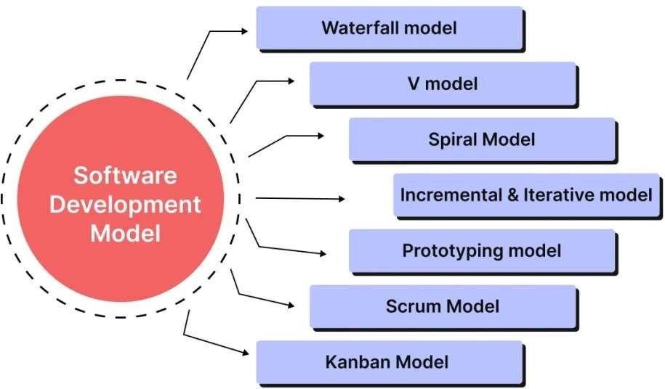

Figure 4.1: Software Development Models

4.2 Benefits of Selected Model
Agile offers several advantages that align well with e-commerce development:
- Flexibility & Adaptability
  - Respond quickly to changing customer or market needs.
  - Integrate stakeholder feedback after each sprint.
- Faster Delivery
  - Deliver working components early (e.g., shopping cart or login system).
  - Reduce time to market and begin generating value sooner.
- Continuous Improvement
  - Frequent releases improve the system iteratively.
  - Regular reviews help adapt based on real-time feedback.
- Better Risk Management
  - Early detection of bugs and vulnerabilities.
  - Prioritize core features (e.g., payment, product catalog).
- High Collaboration
  - Cross-functional teams work in sync via daily stand-ups and sprint reviews.
  - Increased transparency and visibility for stakeholders.
- Enhanced Quality
  - Continuous integration and testing ensure stable, high-quality software.
  - User-centric approach ensures alignment with real needs.
- Improved Customer Satisfaction
  - Involve customers throughout development.
  - Deliver early value through prioritized, usable features.

4.3 Limitations of Selected Model
Despite its strengths, Agile presents several challenges:
- Requires Skilled Team
  - Teams need experience with Agile and technical expertise.
  - Self-organizing teams may struggle without proper guidance.
- Time Demands from Stakeholders
  - Frequent feedback and participation are required.
  - Regular meetings may be burdensome, especially across time zones.
- Scope Creep
  - Frequent changes can lead to uncontrolled feature expansion.
  - Lack of a clear long-term roadmap may affect focus.
- Limited Documentation
  - Emphasis on working software often reduces documentation.
  - Can hinder onboarding or future maintenance if team members leave.
- Uncertain Timelines & Budgets
  - Iterative nature makes it hard to predict project completion and cost.
  - Scope changes may result in budget overruns.
- Less Suitable for Small Teams/Projects
  - Agile roles (Scrum Master, Product Owner) may strain small teams.
  - Agile overhead can outweigh benefits for simple projects.

4.4. Design
The design phase defines the structure and interaction of the Online Cosmetic Store system. A solid design ensures the platform is scalable, user-friendly, and aligned with business needs.
Design is divided into two main parts:

1. System Architecture Design
The system follows a client-server model, where the front-end communicates with the back-end over the web.
Key Components:
- Frontend (Client-Side):
  - Technologies: HTML, CSS, JavaScript, AJAX
  - Handles product display, shopping cart, user login, and payments.
  - Designed to be responsive and easy to navigate.
- Backend (Server-Side):
  - Technologies: PHP, MySQL
  - Manages business logic, inventory, orders, users, and transactions.
  - Includes an Admin Panel for managing products, users, and orders.
- Database Design:
  - Built using MySQL to store users, products, orders, payments, and reviews.
  - ER Diagram defines relationships between entities.
  - Database is normalized to reduce redundancy and improve efficiency.
- Payment Gateway Integration:
  - Supports PayPal, Stripe, or Razorpay for secure transactions.

2. UI/UX Design
The user interface aims to be clean, attractive, and easy to use across all devices.
Key Principles:
- Simplicity: Straightforward layout for easy browsing and purchasing.
- Consistency: Uniform styles and navigation.
- Responsive Design: Works well on mobile, tablet, and desktop.
- Clear CTAs: Prominent buttons like “Add to Cart,” “Buy Now,” and “Checkout.”
- Visual Appeal: High-quality images and clear product descriptions.
Wireframes and Prototypes:
Wireframes show the layout of main pages like the home, product, and checkout pages. Prototypes simulate user actions and help test usability before development.

4.4.1. Data Flow Diagram (DFD)
A DFD shows how data moves through the system and how different components interact.

Level 0: Context Diagram
Provides an overview of the entire system as a single process interacting with:
- Entities:
  - Customer (browses and orders products)
  - Admin (manages system data)
  - Payment Gateway (handles payments)
- Data Stores:
  - Product Database
  - User Database
  - Order Database

Level 1 DFD: Detailed Processes
Breaks down the main process into sub-processes:
- Processes:
  - Browse Products
  - Add to Cart
  - Place Order
  - Payment Processing
  - Order Confirmation
- Data Stores:
  - Product Database
  - Shopping Cart
  - Order Database
- External Entities:
  - Customer
  - Admin
  - Payment Gateway
Example Data Flow:
- Customer browses → data from Product DB
- Adds to cart → stored in Shopping Cart
- Places order → payment processed via Payment Gateway
- On success → details saved in Order DB, confirmation sent
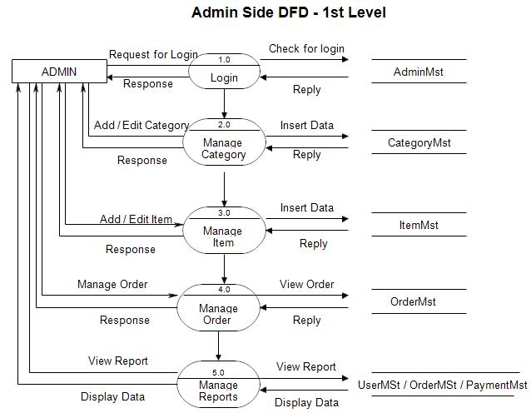
Figure 4.2: Data Flow Diagram

4.4.2. Entity Relationship Diagram (ERD)
The ERD visually represents the entities within the Online Cosmetic Store system and their interrelationships, ensuring efficient database design.
Entities and Attributes:
- Customer: Users who browse and order products.
Attributes: CustomerID, FirstName, LastName, Email, Password, Phone, Address
- Product: Items available in the store.
Attributes: ProductID, Name, Description, Price, Category, StockQuantity, Image
- Order: Orders placed by customers.
Attributes: OrderID, CustomerID, OrderDate, Status, TotalAmount
- OrderItem: Products within each order.
Attributes: OrderItemID, OrderID, ProductID, Quantity, Price
- Payment: Payment details for orders.
Attributes: PaymentID, OrderID, PaymentDate, Amount, PaymentMethod, Status
- Category: Product classifications (e.g., skincare, makeup).
Attributes: CategoryID, CategoryName, Description
- Admin: System managers.
Attributes: AdminID, Username, Password, Role
Key Relationships:
- One Customer places many Orders.
- One Order has many OrderItems; each OrderItem links to one Product.
- Each Product belongs to one Category.
- One Order has one Payment.
- One Admin manages multiple Products, Orders, and Customers.

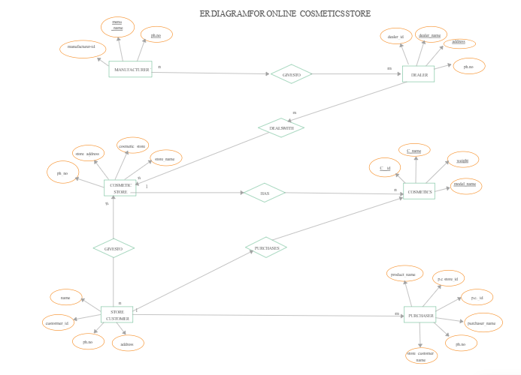
Figure 4.3: ER Diagram

4.4.3. Class Diagram
The Class Diagram shows the system’s structure through classes, their attributes, methods, and interactions.
Main Classes:
- Customer
Attributes: customerID, name, email, password, phone, address
Methods: register(), login(), viewProduct(), addToCart(), placeOrder()
- Product
Attributes: productID, name, category, price, description, image, stockQuantity
Methods: viewProductDetails(), addProduct(), updateProduct()
- Order
Attributes: orderID, customerID, orderDate, status, totalAmount
Methods: createOrder(), viewOrder(), updateOrderStatus()
- OrderItem
Attributes: orderItemID, orderID, productID, quantity, price
Methods: viewOrderItem(), updateQuantity()
- Payment
Attributes: paymentID, orderID, paymentDate, amount, paymentMethod, paymentStatus
Methods: processPayment(), viewPaymentDetails()
- Admin
Attributes: adminID, username, password
Methods: addProduct(), updateProduct(), viewOrders(), manageCustomers()
- Category
Attributes: categoryID, categoryName, categoryDescription
Methods: viewCategory(), addCategory()
Relationships mirror those in the ERD, such as Customer-Order (1:M), Order-OrderItem (1:M), and Product-Category (M:1).
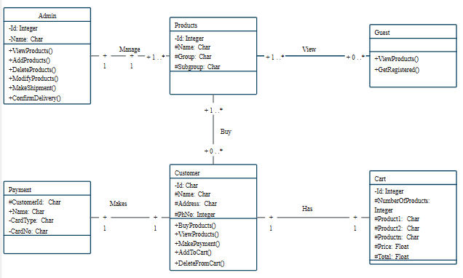
Figure 4.4: Class Diagram

UML Diagram
A Use Case Diagram in Unified Modeling Language (UML) represents the interactions between users (actors) and a system. Here's an explanation of the Use Case Diagram for your Online Cosmetic Store project:

Actors:
- Customer: The primary user of the system who interacts with the online store.
- Admin: The user responsible for managing the system and its contents.
- Payment Gateway: An external system responsible for processing payments.

Use Cases:

Customer:
- Register: Allows customers to create an account in the system.
- Login: Enables customers to authenticate and access their account.
- Browse Products: Allows customers to view available cosmetic products.
- Add to Cart: Customers can add products they wish to purchase to their shopping cart.
- View Cart: Enables customers to view the products currently in their shopping cart.
- Place Order: Customers finalize their selection and place an order.
- Make Payment: Customers initiate payment through the integrated payment gateway.

Admin:
- Login: Enables the admin to authenticate and access administrative functionalities.
- Manage Products: Allows the admin to add new products, update existing ones, or remove products from the store.
- Manage Orders: The admin can view orders, process them, update their status, and manage order details.
- Manage Customers: Enables the admin to view and update customer information stored in the system.

Payment Gateway:
- Process Payment: Represents the external system's function to handle payment transactions securely.

Explanation:
- Actors: Represent the roles interacting with the system. In this case, customers, admin, and an external payment gateway.
- Use Cases: Describe specific actions or functionalities the system provides to its users (actors). Each use case represents a specific goal or task that a user can perform with the system.
- Relationships: Use Case Diagrams show relationships between actors and use cases through associations (lines) connecting them. For example, customers interact with use cases like Register, Browse Products, and Make Payment.
- System Boundaries: The diagram also helps in defining the scope of the system by identifying what functionalities are available to which actors.
By visualizing these interactions and functionalities, the Use Case Diagram provides a clear overview of how users will interact with your Online Cosmetic Store system, helping in both design and understanding of system requirements.

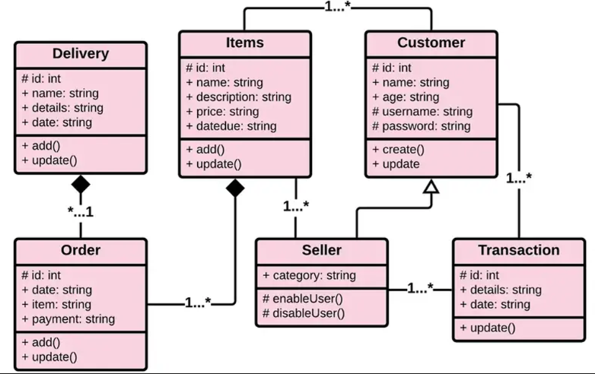
Figure 4.5: UML Diagram

Summary
In this section, we covered the following diagrams:
- Class Diagram: Illustrates the structure of the system, including classes such as Customer, Product, Order, OrderItem, Payment, Admin, and Category, along with their attributes, methods, and relationships.
- UML Use Case Diagram: Represents the interactions between users (actors) and the system’s functionalities. It shows how Customers, Admins, and the Payment Gateway interact with the system.
These diagrams serve as a blueprint for both the database and the application logic, aiding developers
in understanding the structure and functionality of the Online Cosmetic Store system.

4.4.5. Sequence Diagram
The Sequence Diagram illustrates the interaction between system components over time for a specific scenario—in this case, a customer placing an order in the Online Cosmetic Store.
Actors and Objects:
- Customer: Initiates actions such as login and order.
- System: Handles product display, order processing, and communication with the payment gateway.
- Cart: Temporarily stores selected items.
- Order: Captures final order details.
- Payment Gateway: External service for payment processing.
Scenario: Placing an Order
- Login
Customer → System: login()
- Browse & Add Products
Customer → System: viewProduct()
System → DB: Fetch product details
Customer → Cart: addToCart()
- Checkout
Customer → System: placeOrder()
System → Order: createOrder()
- Payment Processing
System → Order: calculateTotal()
System → Payment Gateway: processPayment()
Payment Gateway → System: paymentStatus()
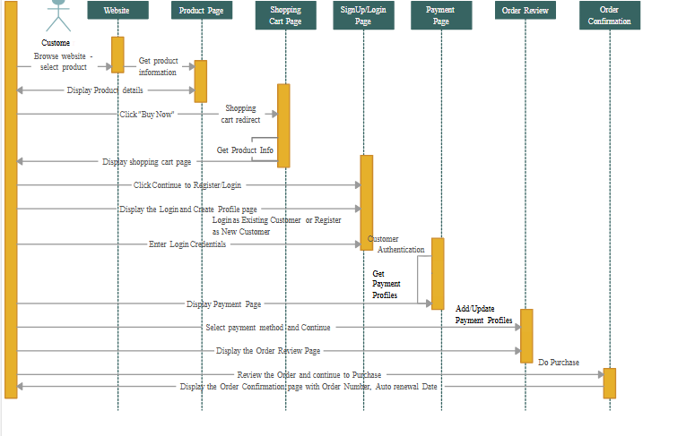
- Order Confirmation
System → Customer: orderConfirmation()
Figure 4.6: Sequence Diagram

4.4.6. Activity Diagram
An Activity Diagram visualizes the dynamic workflow of the Online Cosmetic Store, from product selection to order completion.
Main Activities:
- Customer: Browse → Add to Cart → Checkout → Login/Register → Place Order → Make Payment → Receive Confirmation
- System: Display Products → Update Cart → Validate Payment → Generate Order Confirmation
- Admin: Manage Products → View/Process Orders → Manage Customers
- Payment Gateway: Process Payment → Confirm Payment
Flow Description:
- Start: Customer visits the store.
- Browse Products: System displays products; customer selects items.
- Add to Cart: System updates cart based on customer input.
- View Cart & Checkout: Customer proceeds to place an order.
- Login/Register: If not logged in, the system prompts for authentication.
- Place Order: System processes the order.
- Payment: Payment Gateway handles the transaction and sends status.
- Confirmation: System confirms the order; process ends.
- Admin: Independently manages products and orders.
Diagram Components:
- Start/End Nodes: Represent entry and exit points of the process.
- Action Nodes: Indicate system and user actions.
- Decision Nodes: Handle conditional paths (e.g., login required).
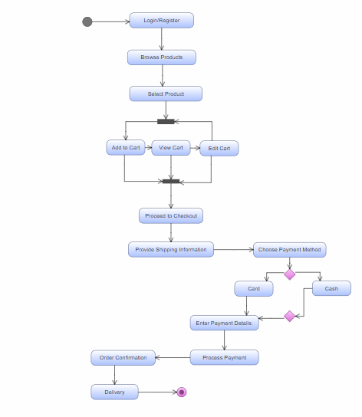
Figure 4.7: Activity Diagram

4.5. Chapter Summary
In this chapter, we discussed:
- Software Process Model: The methodology used to develop the Online Cosmetic Store system, with details about the phases and steps involved.
- Benefits of the Selected Model: The advantages of the chosen software process model were highlighted, emphasizing how it ensures systematic development and management of the project.
- Limitations of the Selected Model: We reviewed the limitations of the selected software process model, such as potential rigidity in the development process.
- Design: Various design diagrams were presented, including the Data Flow Diagram (DFD), Entity Relationship Diagram (ERD), Class Diagram, UML Diagram, and Sequence Diagram. These diagrams helped visualize the structure, components, and interactions within the system.
This chapter provided a comprehensive understanding of how the system is designed and the flow of interactions among its components. The diagrams presented serve as the blueprint for the development and implementation of the Online Cosmetic Store system, ensuring clarity and structure for developer.

INTRODUCTION TO DATABASE

5.1 Introduction to Database
The database is the backbone of any data-driven web application. In the Online Cosmetic Store, it manages key information such as customer accounts, product listings, shopping carts, and orders.
This project uses MySQL, a relational database system that organizes data into related tables using primary and foreign keys to ensure integrity and consistency.

Purpose of the Database
- User Management: Stores customer data like names, emails, and login credentials.
- Product Catalog: Maintains product info including name, category, price, image, and description.
- Shopping Cart: Temporarily stores selected items until checkout.
- Order Processing: Saves order details such as total amount, items, and status.
- Session Handling: Tracks user session activities like cart contents.
- Contact Messages: Stores user-submitted inquiries and feedback.

Key Tables and Roles
Table Name | Description
customers | Registered customer details
products | Cosmetic product data
cart | Items added to the shopping cart
orders | Finalized orders
order_items | Specific products in each order
contact | Contact form submissions

Database Characteristics
- Relational Structure: Ensures organized, interrelated data.
- Data Normalization: Reduces redundancy, enhances integrity.
- Referential Integrity: Enforced with foreign keys.
- Scalability: Handles growing product and user data.
- Security: Passwords should be hashed; PHP ensures secure data access.
Example: When a user logs in and adds products to the cart, data is tracked through their session (customer_id) and updated across cart, orders, and order_items.

5.2 Why SQL?
SQL (Structured Query Language) is the standard for interacting with relational databases like MySQL. It's used throughout this project for tasks like creating tables, querying data, and managing transactions.

Why SQL?
- Readable Syntax: Simple and intuitive for developers.
- Powerful Queries: Supports joins, filters, and aggregations.
- PHP Integration: Works seamlessly with PHP using mysqli or PDO.
- Security: Prepared statements prevent SQL injection.
- Data Integrity: Ensures consistent and valid data.
- Scalability: Handles large datasets and user traffic efficiently.

Common SQL Operations
Operation | SQL Example
User Login | SELECT * FROM customers WHERE email=? AND password=?;
Add to Cart | INSERT INTO cart (product_id, customer_id, quantity) VALUES (...);
View Products | SELECT * FROM products ORDER BY name;
Place Order | INSERT INTO orders (customer_id, total_price) VALUES (...);
View Orders | SELECT * FROM orders WHERE customer_id=?;
Add Product | INSERT INTO products (name, category, price, image) VALUES (...);
Key SQL functions include SELECT, INSERT, UPDATE, DELETE, JOIN, and table management commands like CREATE and ALTER.

5.3 Database Structure
The database is designed using relational principles, normalized to at least Third Normal Form (3NF) to ensure integrity and reduce redundancy.

Entities and Descriptions
Entity | Description
customers | User account information
products | Cosmetic product details
categories | Product classification
cart | Temporary storage for selected products
orders | Finalized customer orders
order_items | Specific products in each order
contact | User-submitted inquiries or feedback

Key Tables Overview
- customers
- Fields: customer_id (PK), name, email, password, address, phone, created_at
- products
- Fields: product_id (PK), name, description, category_id (FK), price, image, stock
- categories
- Fields: category_id (PK), name, description
- cart
- Fields: cart_id (PK), customer_id (FK), product_id (FK), quantity, added_at
- orders
- Fields: order_id (PK), customer_id (FK), total_price, order_date, status
- order_items
- Fields: item_id (PK), order_id (FK), product_id (FK), quantity, price
- contact
- Fields: contact_id (PK), name, email, subject, message, submitted_at

Entity Relationships
- One-to-Many: One customer → many orders; one category → many products.
- Many-to-Many: Orders ↔ products (via order_items).
This structure ensures efficient data access, integrity, and scalability, supporting all key functions of the Online Cosmetic Store.
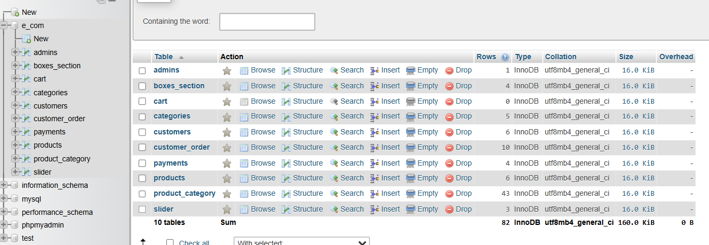
Figure 5.1: Database Structure

DEVELOPMENT

6.1 Introduction
System implementation is the phase where design becomes a functioning application. This chapter outlines the steps taken to build and deploy the Online Cosmetic Store, including coding, configuration, and system integration.
This full-stack web application allows users to browse, select, and purchase cosmetic products. Implementation covers both front-end and back-end development, supported by a MySQL database.

Technologies Used
- HTML & CSS – Page structure and styling
- JavaScript – Dynamic client-side interactions
- PHP – Server-side scripting and business logic
- MySQL – Data storage and management
- Apache (XAMPP) – Local development server
This section details environment setup, database creation, file configuration, and integration to deliver full functionality.

6.2 Setting Up the Development Environment
A proper development environment is essential to ensure smooth coding, testing, and deployment.

1. Tools & Technologies
Tool/Technology | Purpose
XAMPP | Local web server (Apache + MySQL + PHP)
PHP | Backend scripting
MySQL | Relational database management
phpMyAdmin | GUI for MySQL
VS Code / Sublime | Code editor
Chrome/Firefox | Application testing

2. Installing XAMPP
XAMPP simplifies local development by bundling Apache, MySQL, and PHP.
Steps:
- Download from: https://www.apachefriends.org
- Install and launch the XAMPP Control Panel
- Start Apache and MySQL

3. Creating the Database
Use phpMyAdmin via http://localhost/phpmyadmin/:
- Click New and create a database (e.g., e_com or cosmetic_store)
- Create the following tables using the schema from Chapter 5:
  - customers, products, categories, orders, order_items, cart, contact
Each table should include appropriate primary keys, foreign keys, and data types.

4. Project Directory Setup
- Copy your project folder (e.g., e_com) to: C:\xampp\htdocs\
- Access it via browser: http://localhost/e_com/
- Ensure index.php is the landing page

5. File Structure Overview
/e_com
├── index.php → Homepage
├── login.php → User login
├── register.php → User registration
├── products.php → Product listings
├── cart.php → Cart view
├── checkout.php → Checkout process
├── admin/
│ ├── dashboard.php → Admin dashboard
│ ├── manage_products.php → Add/edit/delete products
│ └── orders.php → View/manage orders
├── includes/
│ ├── db.php → DB connection
│ ├── header.php
│ └── footer.php
└── css/
└── style.css → Stylesheet

6. Database Connection (db.php)
<?php
$servername = "localhost";
$username = "root";
$password = "";
$database = "e_com";

$conn = new mysqli($servername, $username, $password, $database);

if ($conn->connect_error) {
die("Connection failed: " . $conn->connect_error);
}
?>
Include this file on every page that interacts with the database.

7. Running the Application
- Start Apache and MySQL from XAMPP
- Navigate to http://localhost/e_com/
- Test core functionality:
  - Register/login as a user
  - Browse products
  - Add to cart and place orders
  - Check admin dashboard for order management

8. Testing the Environment
Verify the following modules:
- User registration and authentication
- Product search and display
- Cart management and total calculation
- Order processing and database updates
- Admin controls for product/order management

6.3 Implementation of Key Features
The Online Cosmetic Store integrates essential e-commerce features to provide a smooth and functional user experience. This section outlines how key modules are implemented using PHP, MySQL, HTML, CSS, and JavaScript.

1. User Registration and Login System
Purpose:
Enables users to create accounts, log in, and access features like personalized checkout and order history.
Front-End:
- Registration Form (register.php): Collects name, email, password, address, and phone number.
- Login Form (login.php): Accepts email and password for authentication via a POST request.
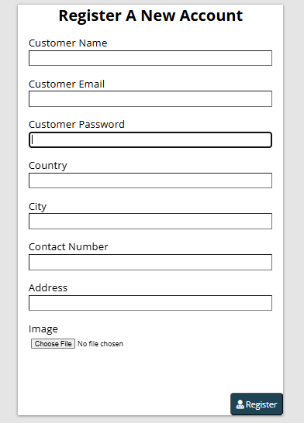

Figure 6.1: User Registration
Figure 6.1: User Registration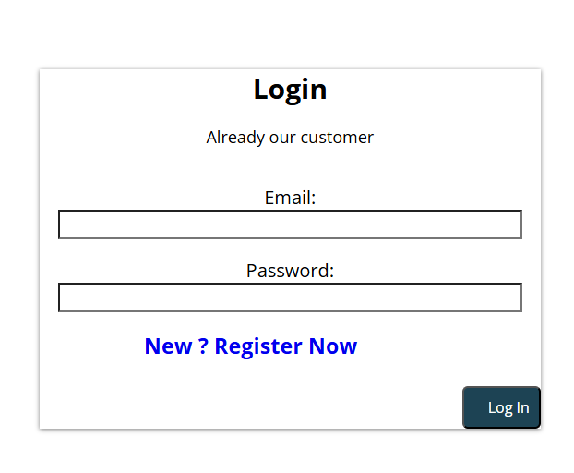
Figure 6.2: Login System
Back-End:
- Registration data is submitted to a PHP script and inserted into the customers table.
- Passwords should be securely hashed using functions like password_hash().
- PHP sessions ($_SESSION) track logged-in users across pages.
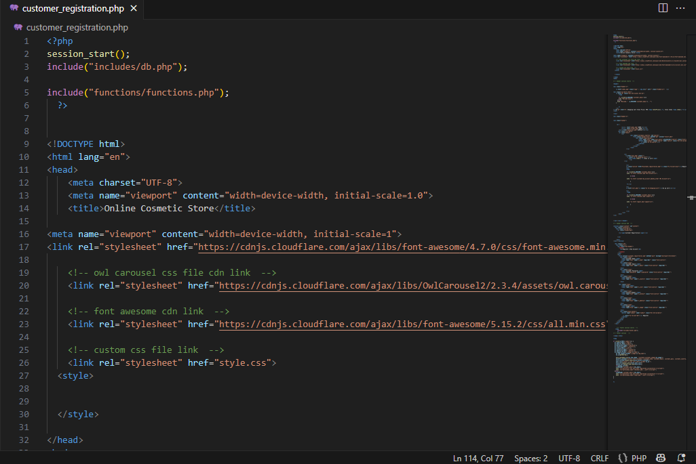
Figure 6.3: User Registration (Code)
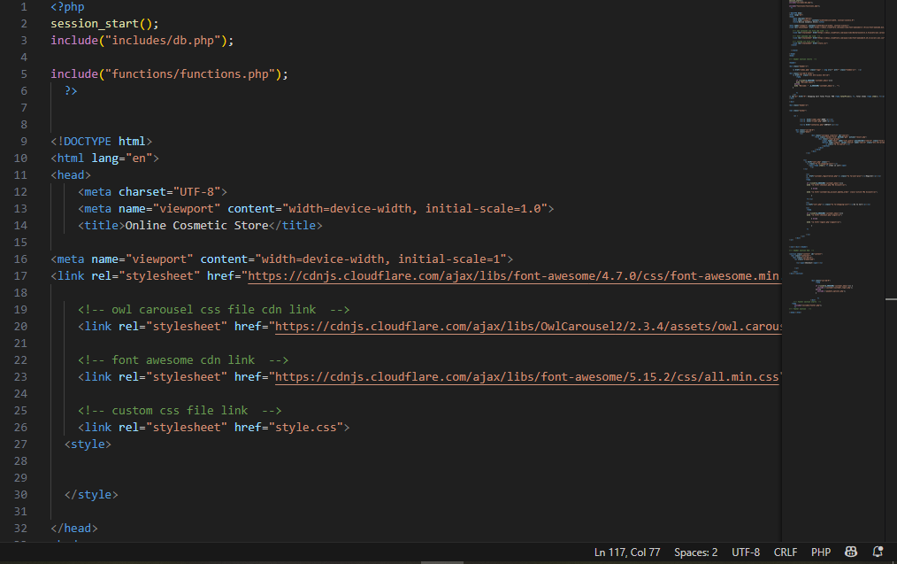

Figure 6.4: Login System(Code)

2. Dynamic Product Display
- Purpose: Enables users to view products by categories or latest listings.
- Front-End:
  - Products are displayed using HTML cards/grid layout with CSS styling.
  - Images, prices, and descriptions are dynamically populated.
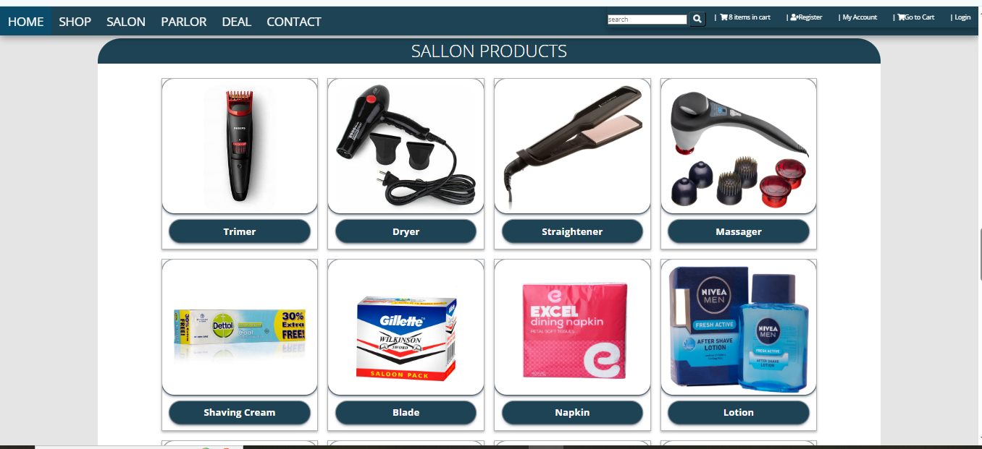
Figure 6.5: Dynamic Product Display

- Back-End:
  - Products are fetched from the products table using PHP and MySQL SELECT queries.
  - Users can view specific products using details.php?id=product_id.
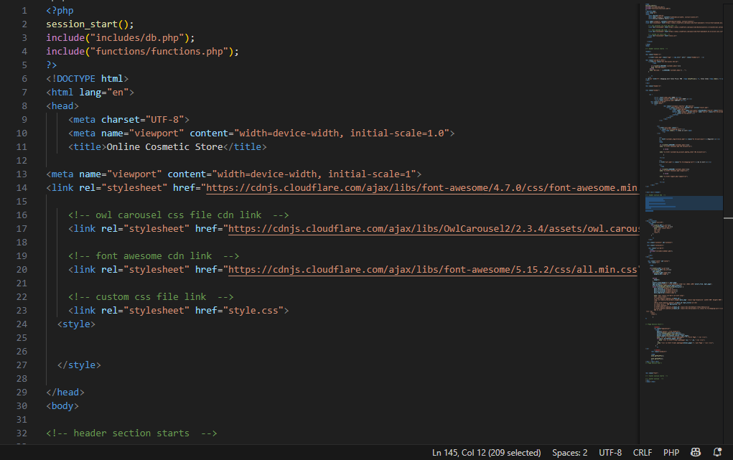
- Figure 6.6: Dynamic Product Display(Code)

3. Product Search Functionality
- Purpose: Helps users find specific products by keyword or category.

- Front-End: Search bar in the header allows input of keywords.
Figure 6.7: Product Search Functionality
- Back-End:
  - PHP handles the search query using $_GET parameters.
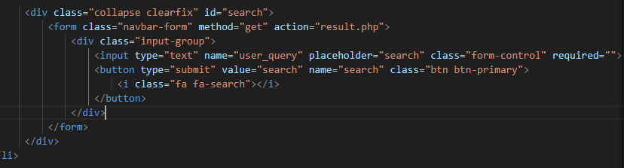
  - SQL LIKE operator is used to retrieve matching products from the database.

Figure 6.8: Product Search Functionality(Code)

4. Shopping Cart
- Purpose: Allows customers to select and review items before purchase.
- Front-End:
  - cart.php displays selected items in a table with quantity controls.
  - JavaScript is used for dynamic interactions like quantity adjustment.
  - 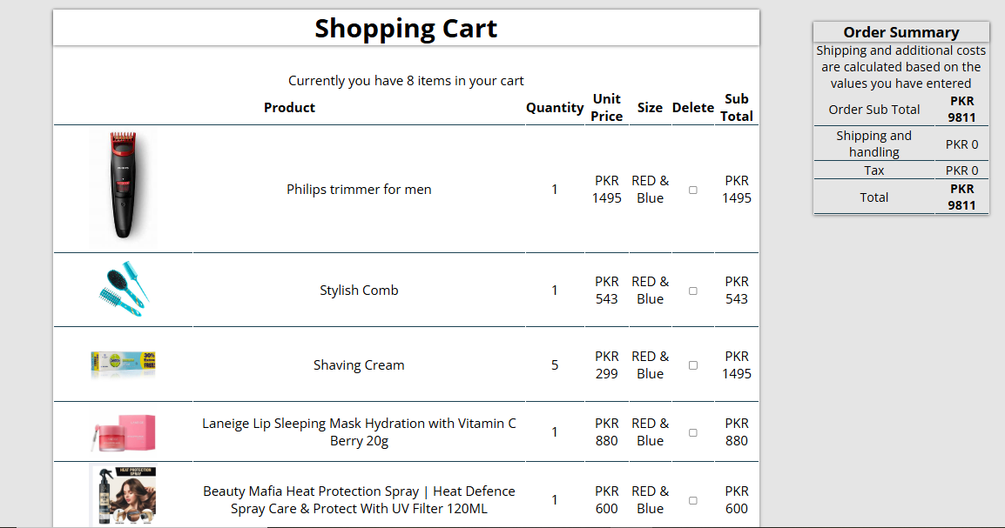
- Figure 6.9: Shopping Cart
Back-End:
  - The cart table in the database stores user-selected products with quantity and price.
  - Items are added using add_to_cart.php, updated via form actions, and removed with delete actions.
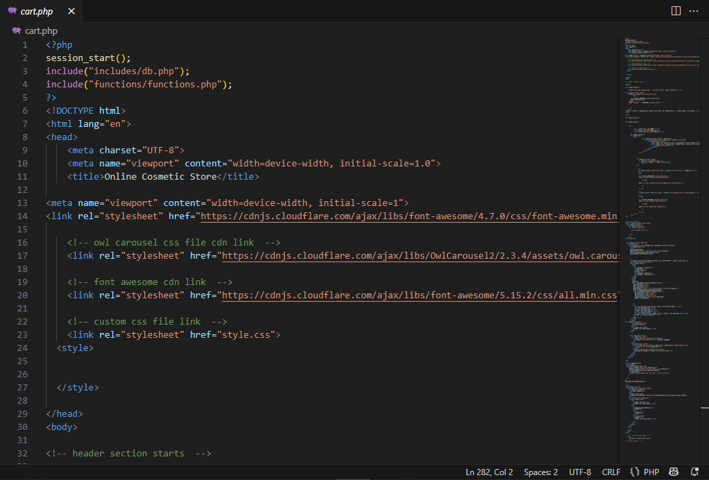

Figure 6.10: Shopping Card(Code)

5. Checkout and Order Placement
- Purpose: Finalizes the user's purchase process.
- Front-End:
  - Displays cart summary, total amount, and payment options.
  - Provides a form to collect delivery details if not already in user profile.
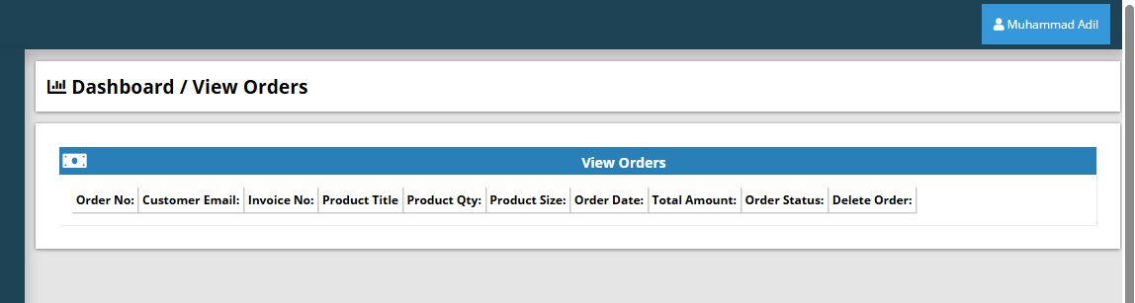

  - Figure 6.11: Checkout and Order placement
- Back-End:
  - Once the order is placed, data is transferred from cart to orders table.
  - A unique order_id is generated, and status is set to Pending by default.
  - Email confirmation may be triggered (if implemented).

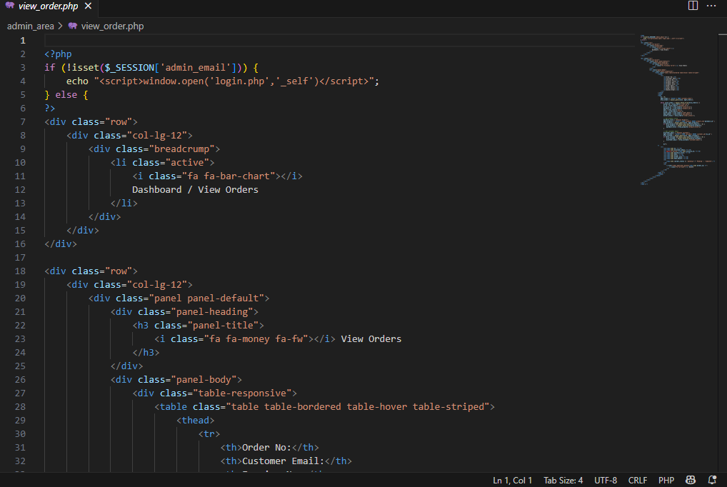

Figure 6.12: Checkout and Order placement(Code)

6. Admin Panel and Dashboard
- Purpose: Allows administrators to manage the store.
- Access: Located at admin_area/index.php.
- Features:
  - Product Management: Add/Edit/Delete products with image upload.
  - Category Management: Organize products into categories.
  - View Orders: View list of all placed orders with user details.
  - User Management: View or remove registered customers.
  - Slider Management: Upload promotional banners for homepage.
  - 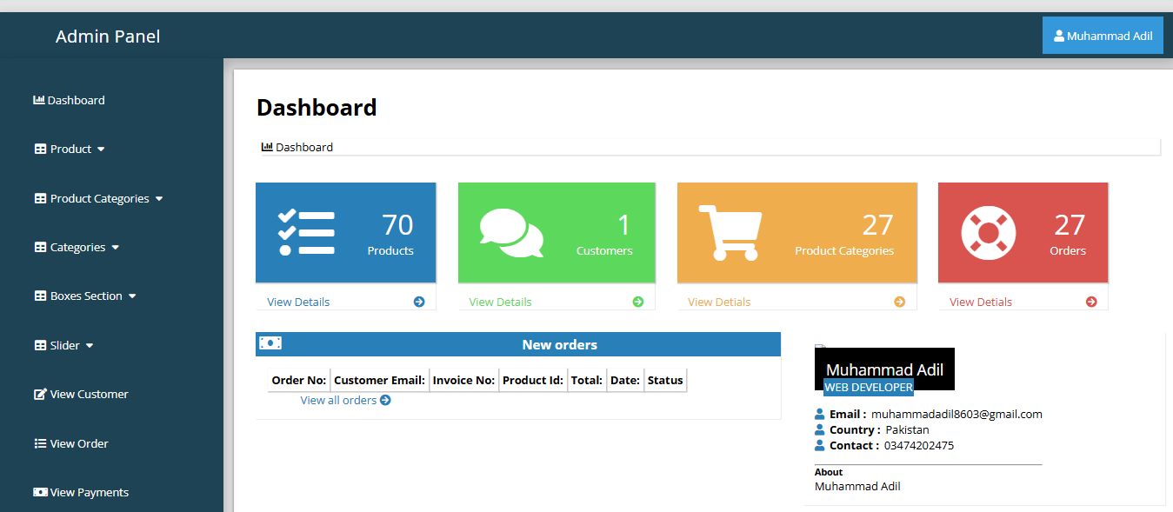
Figure 6.13: Admin Panel and Dashboard

8. Image and Slider Management
- Purpose: Display promotional content on the homepage.
- Front-End:
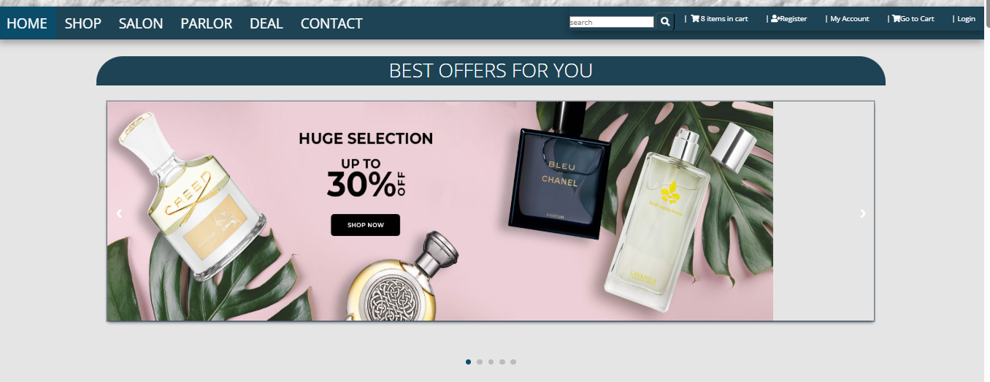
  - A JavaScript or CSS-based image slider showcases promotional banners.

Figure 6.14: Image and Slider Management

- Back-End:
  - Admins can upload new slider images through the admin panel.
  - Images are stored in a director (e.g., images/sliders) and referenced via PHP.
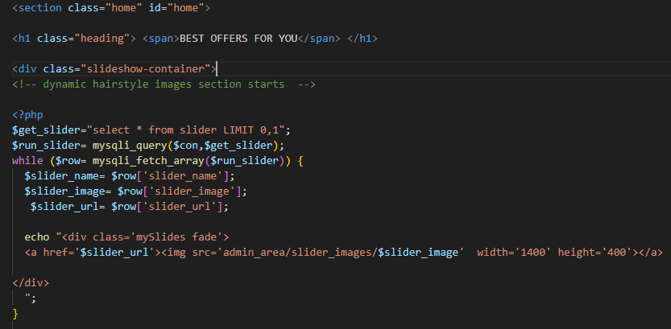

Figure 6.15: Image and Slider Management(Code)

9. Contact Form and Feedback Handling
- Purpose: Allows users to send messages or inquiries.
- Front-End:Contact form with fields like name, email, subject, and message.

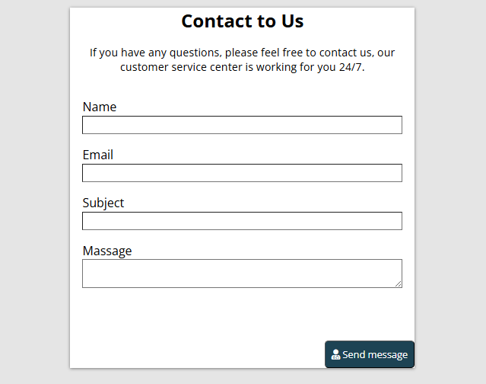

Figure 6.16: Contact Form and Feedback Handling
- Back-End:
  - PHP script processes the form and stores messages in the database or sends them via email (if configured).
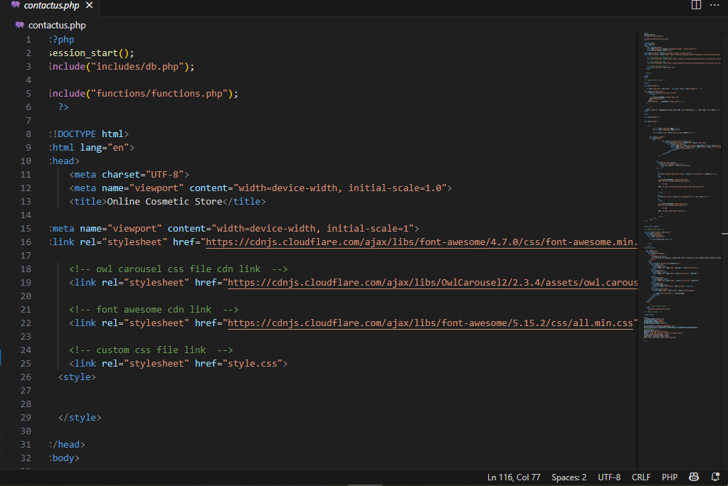

Figure 6.17: Contact Form and Feedback Handling(Code)

10. Logout and Session Handling
- Purpose: Ends the user session securely.
- Implementation:
  - logout.php clears the session using session_destroy() in PHP.
  - Redirects the user to the homepage after logout.

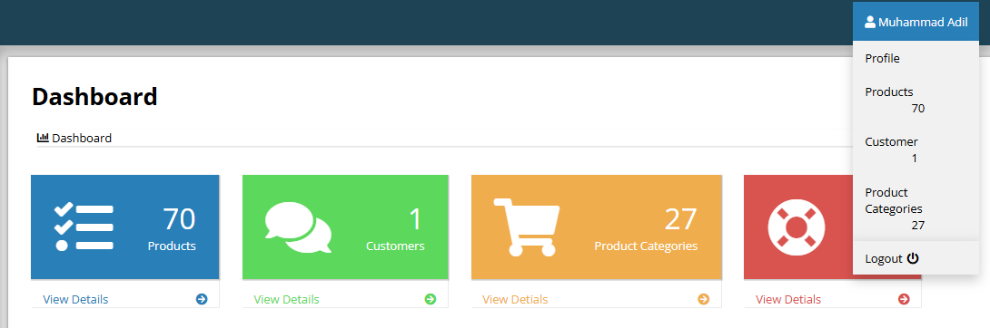

Figure 6.18: Logout and Session Handling
11. Category: Product Management
The Product Management category is responsible for handling all cosmetic items available in the online store. This includes adding new products, updating existing ones, managing product categories (such as skincare, makeup, haircare, etc.), and uploading product images and details. Only the admin has access to this module to ensure control and consistency over the product catalog.
Each product record contains essential information such as the product name, brand, category, price, stock quantity, description, and an image. This module ensures that users are presented with accurate and updated product information when browsing or making purchases.
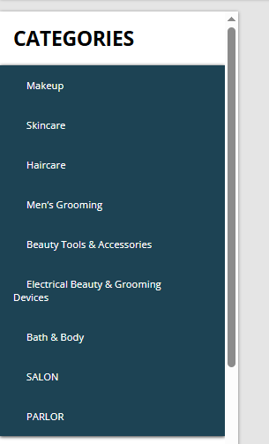
It plays a critical role in maintaining the inventory and improving the user experience by showcasing products in an organized and visually appealing manner.

Figure 6.19: Category: Product Management

TESTING

7.1 Introduction
Testing is a vital phase in the Software Development Life Cycle (SDLC), ensuring the system functions as intended and delivers a reliable, bug-free user experience. For the Online Cosmetic Store, testing verifies both the front-end and back-end components, particularly focusing on:
- Seamless navigation and user interaction
- Functionality of registration, login, cart, and checkout
- Data accuracy and consistency in the database
- Proper operation of the admin panel
- Cross-browser compatibility and responsiveness

7.2 Testing Strategies
A variety of testing methods were used to ensure the quality and performance of the application:

1. Unit Testing
Purpose:
Test individual components (e.g., functions, forms) in isolation.
Tools & Techniques:
- Manual testing using echo, var_dump, and browser console
- SQL queries tested directly in phpMyAdmin
Examples:
- Validating login credentials
- Checking product retrieval accuracy

2. Integration Testing
Purpose:
Verify that multiple modules work together as expected.
Focus Areas:
- Registration data saved to the customers table
- Product data displayed dynamically on the homepage
- Cart sessions syncing with the cart table

3. System Testing
Purpose:
Test the complete system workflow.
Test Scenarios:
- Full order process (registration to confirmation)
- Admin adds a product → visible to users
- Order status changes reflected in user history

4. Functional Testing
Purpose:
Ensure each feature works as per requirements.
Functionality | Expected Result | Status
User registration | Account created and redirected to login | ✅ Passed
Login authentication | Valid login accepted, invalid rejected | ✅ Passed
Add to cart | Correct product and quantity added | ✅ Passed
Checkout | Order processed and confirmation shown | ✅ Passed
Admin product update | Changes reflected on user-facing product list | ✅ Passed

5. User Interface Testing
Purpose:
Ensure a clean, consistent, and user-friendly interface.
Focus Areas:
- Proper placement of forms and buttons
- Consistent color themes and layout
- Visible and accessible navigation elements

6. Security Testing
Purpose:
Protect the system from vulnerabilities.
Tests Conducted:
- Session management: Restricted access after logout
- SQL injection attempts: Input sanitization in login, search, contact forms
- Admin access: Restricted to authenticated users

7. Database Testing
Purpose:
Verify data integrity and relationships.
Tests Included:
- Correct data insertion during registration/orders
- Relationship validation between orders, products, categories
- Deletion consistency across modules (e.g., cart, admin panel)

8. Cross-Browser Testing
Purpose:
Ensure consistency across major browsers.
Browsers Tested:
- Google Chrome
- Mozilla Firefox
- Microsoft Edge
Result:
Functionality consistent across all; minor layout issues in Firefox were resolved with CSS resets.

9. Responsive Testing
Purpose:
Test adaptability across devices and screen sizes.
Tools Used:
- Chrome Developer Tools (Device Mode)
- Physical mobile and tablet testing
Result:
- Navigation menu responsive
- Product grid requires improvement with media queries or Bootstrap for better responsiveness

7.2.1 Unit Testing
Definition:
Unit testing involves verifying individual components or functions of the software in isolation to ensure they behave correctly under various conditions.
Objective in This Project:
To ensure that core application units—such as form handlers, database interactions, and logic functions—work as expected independently of other modules.
Scope:
The following components were tested as individual units:
- User registration form
- Login authentication
- Product display logic
- Cart management functionality
- Admin operations (e.g., product addition, category management)
Technologies Used:
- PHP echo, var_dump for debugging
- SQL queries via phpMyAdmin
- JavaScript console logs
- Manual form testing
Testing Methodology:
Each component was tested using:
- Valid inputs to confirm expected functionality
- Invalid inputs to ensure error handling and validation
- Boundary cases, such as max input lengths and empty fields
Examples of Unit Tests:
- User Registration
  - Test: Submit registration with valid input.
  - Expected: New entry in customers table.
  - Result: ✅ Passed
  - Negative Test: Missing email → validation error displayed.
- Admin Add Product
  - Test: Upload product with all required fields.
  - Expected: Record added to products table, image saved correctly.
  - Result: ✅ Passed
- Add to Cart
  - Test: User clicks “Add to Cart.”
  - Expected: Product ID stored in PHP session.
  - Result: ✅ Passed — verified via cart.php.
Outcome:
All tested units behaved as expected. Minor issues (e.g., image path inconsistencies, missing input trimming) were resolved during the development phase.

7.2.2 Integration Testing
Definition:
Integration testing evaluates the interaction between interconnected modules to ensure they function together correctly.
Objective in This Project:
To validate the data flow and functional integration between the front-end, back-end, and database systems.
Scope:
- Registration → Login → Session
- Product Upload → Homepage Listing
- Add to Cart → Checkout → Order Creation
- Session Persistence
- Admin Panel → Order Status → User History
Tools & Methods:
- Simulated manual user scenarios
- phpMyAdmin for backend validation
- Session and cookie tracking via browser tools
- JavaScript console and alert-based debugging
Integration Testing Scenarios:
Scenario | Description | Expected Result | Status
1 | Register → Login | Seamless transition and login success | Passed
2 | Admin adds product | Product appears on homepage correctly | Passed
3 | Add to cart → Checkout | Cart reflects accurate data | Passed
4 | Checkout → Order table | Order recorded and shown in admin panel | Passed
5 | Admin updates order status | Change reflected in user’s order history | Passed
6 | Logout → Session | Session destroyed, access restricted | Passed
Common Issues & Fixes:
Issue | Cause | Resolution
Cart not showing items | Improper session indexing | Updated session structure
Product not visible | Image path error | Corrected upload directory reference
Order creation failed | SQL NULL values | Added default values to database schema

7.2.3 System Testing
Definition:
System testing is a high-level, black-box testing approach where the entire application is tested to ensure it meets all specified functional and non-functional requirements.
Objective:
To validate the full workflow of the Online Cosmetic Store, ensuring smooth user interaction, reliable session handling, accurate data management, and full system integration.
Scope of Testing:
- Complete front-end and back-end interaction
- Database integrity and CRUD operations
- Admin and customer role behavior
- Error handling and user feedback
- Session persistence and security
System Test Cases and Results:
Test Case | Scenario | Expected Output | Result
TC01 | Homepage loads | Product list displayed | Passed
TC02 | User registration | Account created in DB | Passed
TC03 | User login | Session initiated, redirected | Passed
TC04 | Add item to cart | Cart updates with item | Passed
TC05 | Remove from cart | Item removed, total updated | Passed
TC06 | Place an order | Order inserted in DB, confirmation shown | Passed
TC07 | Admin adds product | Product appears to users | Passed
TC08 | User logs out | Redirect to login, session destroyed | Passed
TC09 | Invalid login | Error message displayed | Passed
TC10 | Search for product | Relevant results shown | Passed
Tools Used:
- Manual end-to-end tests in browser
- Developer tools for inspecting network, DOM, and console
- phpMyAdmin for backend verification
- PHP error logs
Conclusion:
System testing confirmed that all modules worked together harmoniously and met the functional requirements defined in the SRS. All test cases passed successfully, and the application exhibited stability during complete user workflows.

7.3 Acceptance Testing
Definition:
Acceptance testing is the final testing phase to verify if the software meets business requirements and is ready for delivery. It is done from the end-user or client’s perspective.
Objective:
To confirm that the Online Cosmetic Store functions as expected and is ready for deployment.
Types of Acceptance Testing:
- User Acceptance Testing (UAT)
- Client Requirement Verification

User Acceptance Testing (UAT)
Test Group:
Selected students and faculty tested common tasks like searching, ordering, and contacting support.
Tasks Performed:
- Account creation & login
- Browse/search products
- Add to cart & place order
- Use contact form
- Logout/login again
Feedback Summary:
- User interface is clean and simple
- Product details are clear
- Cart/order features worked well
- Suggested improved mobile responsiveness
Result: ✅ Passed – Users completed tasks with satisfaction.

7.4 Test Cases
Test cases ensure features work as expected. Each includes:
Test Case ID, Description, Preconditions, Input, Expected Output, Actual Output, Status

7.4.1 User Management
Test Case ID | Description | Input | Expected Output | Status
TC-UM-01 | Valid Registration | Name, Email, Password | Account created | ✅ Pass
TC-UM-02 | Missing Fields | Blank email/password | Error shown | ✅ Pass
TC-UM-03 | Valid Login | Correct credentials | Redirect to homepage | ✅ Pass
TC-UM-04 | Invalid Login | Wrong password/email | Error message | ✅ Pass
TC-UM-05 | Logout | Click logout | Redirect to login | ✅ Pass
TC-UM-06 | Access Profile (no login) | Direct access | Redirect to login | ✅ Pass
TC-UM-07 | Session Persistence | Browse after login | Session maintained | ✅ Pass
Manual testing with browser & database. Edge cases tested separately.

7.4.2 Product Management
Test Case ID | Description | Input | Expected Output | Status
TC-PM-01 | Add Product (valid) | All fields | Product listed | ✅ Pass
TC-PM-02 | Add Product (missing) | Missing name/image | Show error | ✅ Pass
TC-PM-03 | Update Product | New details | Updated info | ✅ Pass
TC-PM-04 | Delete Product | Click delete | Product removed | ✅ Pass
TC-PM-05 | View Products | None | All products shown | ✅ Pass
TC-PM-06 | Invalid Image | Upload .txt file | Upload blocked | ✅ Pass

7.4.3 Cart & Order Management
Test Case ID | Description | Input | Expected Output | Status
TC-OM-01 | Add to Cart | Click "Add" | Product added | ✅ Pass
TC-OM-02 | View Cart | Go to cart | Items listed | ✅ Pass
TC-OM-03 | Update Quantity | Change to 3 | Subtotal updated | ✅ Pass
TC-OM-04 | Remove Item | Click delete | Item removed | ✅ Pass
TC-OM-05 | Place Order | Proceed checkout | Order stored | ✅ Pass
TC-OM-06 | Admin View Orders | Open dashboard | Orders listed | ✅ Pass
TC-OM-07 | Update Order Status | Change status | Updated in history | ✅ Pass

7.5 Testing Tools
1. Chrome DevTools
- Inspected layout, JS errors, sessions, and network
- Helped debug front-end issues
2. phpMyAdmin
- Verified DB entries for users, orders, and products
- Tested SQL operations
3. XAMPP
- Local testing (PHP, MySQL)
- Viewed error logs, ran MySQL
4. Console Logs (JavaScript)
- Tracked variables and UI interactions
5. Manual Test Execution
- End-to-end scenario validation
- Realistic task testing by users

7.5 Testing Tools
A combination of manual testing and web development tools was used to ensure the application’s quality and functionality.
- Chrome Developer Tools (DevTools)
  - Purpose: Inspect HTML/CSS, debug JavaScript, monitor sessions and AJAX requests.
  - Benefit: Helped resolve layout issues and JavaScript errors efficiently.
- phpMyAdmin
  - Purpose: Verify database entries, test SQL queries, debug data-related issues.
  - Benefit: Ensured data accuracy and validated backend transactions.
- XAMPP Control Panel
  - Purpose: Provide a local server environment with PHP, MySQL, and Apache support.
  - Benefit: Enabled complete local testing and error log tracking.
- JavaScript Console Logs and Alerts
  - Purpose: Track variable values and debug user interactions.
  - Benefit: Lightweight and useful for quick client-side testing.
- Manual Test Execution
  - Purpose: Perform end-to-end user flow testing against structured test cases.
  - Benefit: Validated real-world behavior and business logic.

7.6 Testing Results
This section summarizes the evaluation of the testing efforts to ensure functionality and alignment with user requirements.

Overall Testing Summary
Testing Type |  |  |  | Objective | Status
Unit Testing |  |  |  | Validate individual components | ✅ Passed
Integration Testing |  |  |  | Verify module interactions | ✅ Passed
System Testing |  |  |  | Evaluate complete system behavior | ✅ Passed
User Acceptance Testing |  |  |  | Ensure system meets end-user needs | ✅ Passed
Manual UI Testing |  |  |  | Test layout responsiveness and interface logic | ✅ Passed
Functional Testing |  |  |  | Confirm features work as expected | ✅ Passed

Defects Found and Resolved
Bug ID | Issue | Severity | Status | Resolution
BUG-01 | Image not uploading correctly | Medium | Resolved | Fixed file path and type validation
BUG-02 | Cart not updating quantity | High | Resolved | Updated session logic
BUG-03 | Checkout button not redirecting | Low | Resolved | Corrected form action
BUG-04 | Admin dashboard layout misaligned | Low | Resolved | Adjusted CSS layout using Flexbox
BUG-05 | Session not ending after logout | High | Resolved | Cleared all session variables

7.7 Chapter Summary
This chapter detailed the testing phase, emphasizing the importance of ensuring quality, stability, and usability before deployment.

Key Highlights:
- Testing Strategies:
Unit, integration, system, and acceptance testing were conducted to cover all layers of the application.
- Test Cases:
Comprehensive test cases covered critical modules like user management, product handling, and order processing.
- Tools Used:
Tools such as DevTools, phpMyAdmin, and XAMPP were instrumental in identifying and resolving issues effectively.
- Test Outcomes:
All features passed their respective test scenarios, and all reported bugs were resolved.

RESULTS

- 8.1 Introduction
- This chapter outlines the deployment process and maintenance strategy for the Online Cosmetic Store. It explains how the system was made accessible and how it will be maintained and updated over time.
- Once fully developed and tested, the system was deployed locally using XAMPP. This ensures the application is functional and ready for demonstration or future live deployment.
- It also reflects on how the project’s key objectives were achieved and evaluates the overall success.

- 8.2 Achievement of Objectives
- The development was guided by specific objectives set during the planning phase. Below is an evaluation of each:
- Objective 1: Design and Develop a User-Friendly Interface
• A responsive and intuitive interface was created using HTML, CSS, and JavaScript. Users can easily navigate, view products, and manage their cart.
- Objective 2: Implement Secure User Registration and Login
• A secure login system was built using PHP and MySQL. Session management protects access to restricted pages.
- Objective 3: Allow Users to Browse and Search for Products
• Users can browse products by category, search by keywords, and view product details, with data retrieved dynamically from the database.
- Objective 4: Enable Cart and Order Placement Functionality
• Users can add items to the cart, update quantities, and place orders. Orders are stored in the database and linked to user accounts.
- Objective 5: Develop an Admin Dashboard for Product and Order Management
• Admins can manage products and view customer orders through a dedicated dashboard, streamlining backend operations.
- Objective 6: Ensure Data Integrity and Secure Database Storage
• A normalized MySQL database ensures efficient storage and data consistency. Input validation helps prevent SQL injection.
- Objective 7: Conduct Comprehensive Testing of All Features
• Manual and tool-based testing (phpMyAdmin, browser DevTools) was performed at multiple levels to ensure a stable, error-free system.
- Objective 8: Prepare Deployment-Ready Solution and Documentation
• The application was deployed locally with XAMPP. Full documentation covering all development phases has been completed for future upgrades.

- 8.3 Improved Administrative Efficiency
- The system enhances backend efficiency by automating key tasks:
- Key Improvements:
• Product Management: Add, edit, delete products via dashboard.
• Order Tracking: Monitor and update orders in real time.
• User Monitoring: View user activity and details.
• Inventory Control (Basic): Potential to track stock levels.
- Impact:
• Reduces manual effort and errors.
• Improves speed and accuracy of admin tasks.
• Supports smoother business operations.

- 8.4 Enhanced Customer Management and Experience
- The system improves user experience through:
- Key Enhancements:
• Secure, seamless registration and login.
• Clean UI with categorized product views.
• Simple cart and checkout system.
• Access to order history for transparency.
- Benefits:
• Increases customer satisfaction and repeat visits.
• Streamlines the shopping experience.
• Builds trust with reliable order tracking and data handling.

8.5 Effective Communication
Effective communication was vital to the success of the Online Cosmetic Store project. It played a key role throughout the development lifecycle, from requirement gathering to deployment.
Key Areas of Communication:
- Requirement Gathering:
Clear communication with stakeholders ensured accurate capture of both functional and non-functional requirements.
- Team Collaboration (if applicable):
Tools like WhatsApp, Google Docs, and Zoom (if used) enabled real-time coordination, task assignment, and issue resolution.
- Documentation and Reporting:
Written communication was essential for documenting each phase, aiding future maintenance and upgrades.
- User Interface Design:
The system uses intuitive layouts, alerts, and feedback messages to guide users and confirm actions.
Impact:
- Kept development aligned with goals
- Reduced misunderstandings and rework
- Enhanced usability and overall quality

8.6 Benefits to Users
The system offers practical benefits for both customers and administrators:
For Customers:
- Convenient Shopping:
Browse, add to cart, and place orders anytime, from anywhere.
- Detailed Product Info:
Products include images, descriptions, and pricing for informed choices.
- Secure Account Management:
Users can register, log in, and view order history with confidence.
- Time Efficiency:
Eliminates the need to visit physical stores—ideal during lockdowns or for busy users.
For Admins:
- Product Management:
Easily add, update, or delete products through the dashboard.
- Order Tracking:
Monitor and update orders efficiently.
- Business Control:
Gain insights into inventory and customer activity for better decisions.

8.7 Performance Evaluation
The system was evaluated on responsiveness, accuracy, reliability, and user experience.
System Responsiveness:
- Fast page load (1–2 seconds) on XAMPP
- Real-time cart and form feedback via JavaScript
Accuracy & Data Integrity:
- Reliable storage/retrieval of user and order data
- Accurate calculations for cart totals and order summaries
- Admin actions reflected instantly in both UI and database
Reliability:
- Stable during multiple concurrent operations
- No major bugs or crashes during testing
User Experience:
- Simple, clear navigation
- Intuitive product browsing and ordering
- Positive feedback from interface design and usability
Evaluation Summary Table:
Metric | Evaluation
Page Load Time | Fast (1–2 seconds)
Form Validation | Responsive and effective
Database Operations | Accurate and secure
User Navigation | Smooth and intuitive
System Downtime | None during testing
Overall Performance | Satisfactory and consistent

8.8 Limitations and Areas for Improvement
Although the system met its core goals, several limitations exist:
Current Limitations:
- No online payment integration (e.g., PayPal, Stripe)
- Basic inventory control—no stock tracking or alerts
- No email notifications (e.g., for orders or registration)
- Limited security—no password hashing or CSRF protection
- UI not fully responsive for mobile devices
- Single admin user—no support for multiple roles
Future Enhancements:
- Add secure payment gateway integration
- Implement real-time stock tracking
- Improve security (password hashing, CSRF prevention)
- Enable email notifications
- Design for mobile responsiveness (Bootstrap/Tailwind)
- Support user reviews and product feedback
- Deploy the system to a live web server

8.9 Chapter Summary
This chapter covered the deployment and evaluation of the Online Cosmetic Store. It reviewed how the system was delivered, assessed against original goals, and examined for usability and performance.
Key Highlights:
- Objective Fulfillment:
All major goals—from secure login to product/order management—were achieved.
- Admin Efficiency:
Backend tasks were streamlined, reducing effort and errors.
- User Benefits:
Customers enjoyed a smooth and secure online shopping experience.
- Communication Impact:
Clear interaction and UI feedback improved both development and usability.
- Performance:
The system performed well with minimal issues and fast response times.
- Limitations:
Identified gaps offer clear pathways for future development and system enhancement.

REFERENCES
The development of this project was supported by various online resources and academic materials. Below is a list of references used during the research, design, coding, and documentation phases:
- W3Schools – HTML, CSS, JavaScript Tutorials
https://www.w3schools.com/
- PHP Manual – Official Documentation
https://www.php.net/manual/en/
- MySQL Documentation – Structured Query Language and DBMS
https://dev.mysql.com/doc/
- Stack Overflow – Coding Help and Debugging
https://stackoverflow.com/
- GeeksforGeeks – PHP, MySQL and Web Development Resources
https://www.geeksforgeeks.org/
- Bootstrap Documentation (Optional if used)
https://getbootstrap.com/
- XAMPP Installation and Configuration Guide
https://www.apachefriends.org/
- Mozilla Developer Network (MDN) – JavaScript and Web Standards
https://developer.mozilla.org/

